Tracking the path of a cyclone
The image below details the path that Severe Tropical Cyclone Larry took in March 2006.
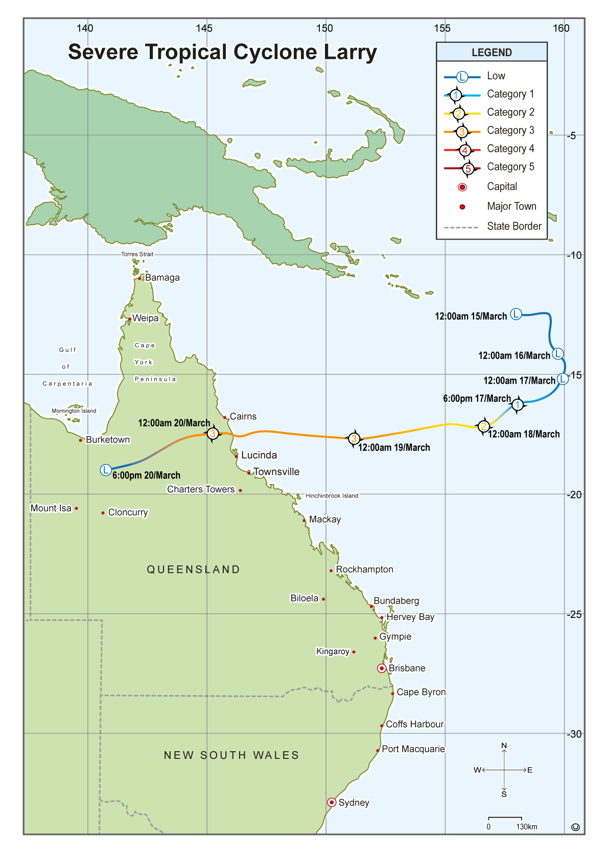
Severe Tropical Cyclone Larry was quite devastating for residents of North Queensland, particularly Innisfail and the other towns between Cairns and Townsville.

